|  |  |
| --- | --- |
| a | i |
| u | e |
| o |  |

|  |  |
| --- | --- |
| ka | ki |
| ku | ke |
| ko |  |

|  |  |
| --- | --- |
| sa | shi |
| su | se |
| so |  |

|  |  |
| --- | --- |
| ta | ti |
| tsu | te |
| to |  |

|  |  |
| --- | --- |
| na | ni |
| nu | ne |
| no |  |

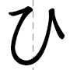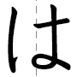

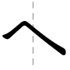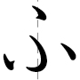

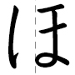

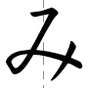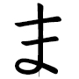

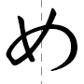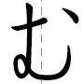

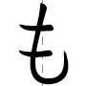

|  |  |
| --- | --- |
| ya | yu |
| yo |  |
|  |  |

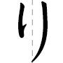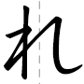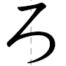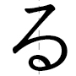

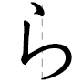

|  |  |
| --- | --- |
| wa | wo |
| nn |  |
|  |  |