|  |  |
| --- | --- |
| A | I |
| U | E |
| O |  |

|  |  |
| --- | --- |
| KA | KI |
| KE | KU |
| KO |  |

|  |  |
| --- | --- |
| SA | SHI |
| SU | SE |
| SO |  |

|  |  |
| --- | --- |
| TA | TI |
| TSU | TE |
| TO |  |

|  |  |
| --- | --- |
| NA | NI |
| NU | NE |
| NO |  |

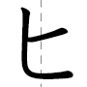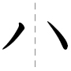

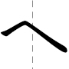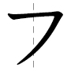

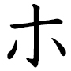

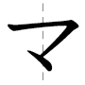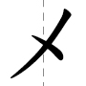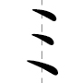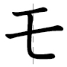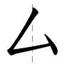

|  |  |
| --- | --- |
| YA | YU |
| YO |  |
|  |  |

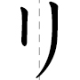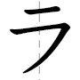

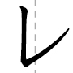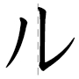

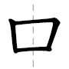

|  |  |
| --- | --- |
| WA | NN |
|  |  |
|  |  |